ПОВТОР ТЕМЫ ПРАЗДНИКОВ-ПРОЧИТАТЬ ВСЕ СЛАЙДЫ И СДЕЛАТЬ ТЕСТ,ПРИСЛАТЬ ОТВЕТЫ МНЕ НА ПОЧТУ
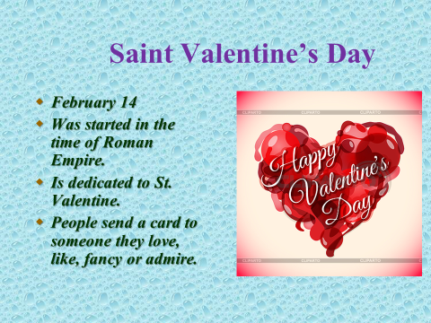

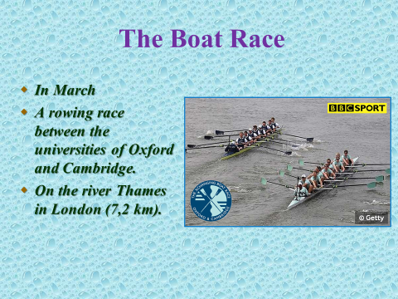

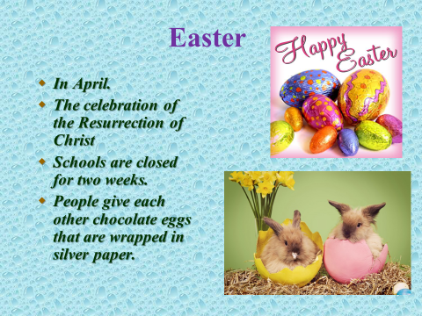

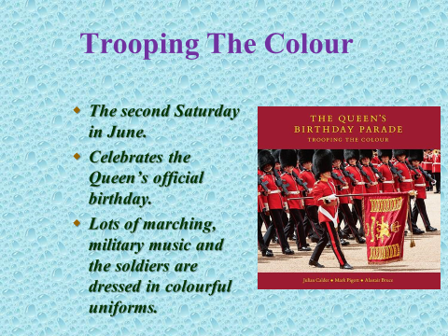

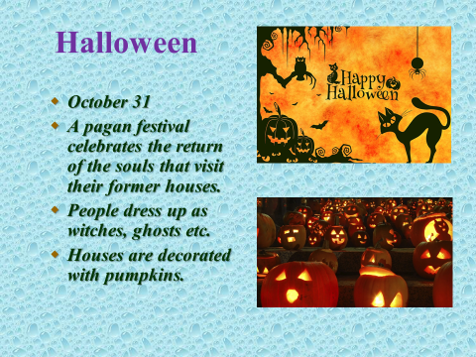

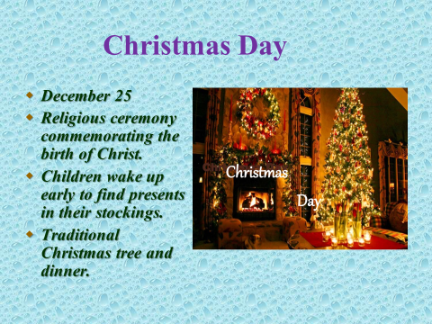

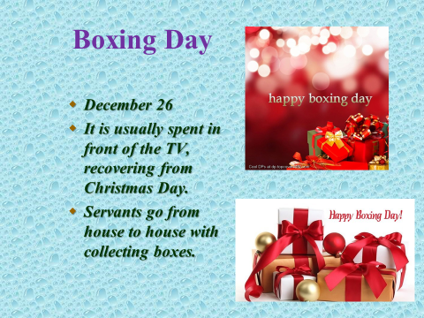

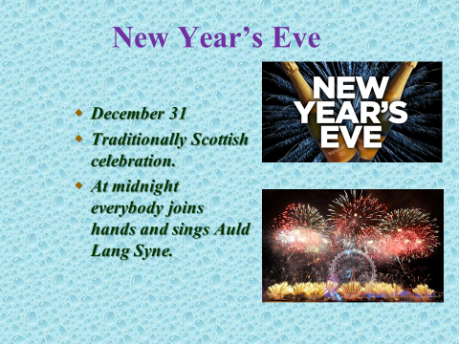

ТЕСТ
1. The British celebrate this holiday on the 1-st of January. It is…
a) New Year b) Christmas c) Easter
2. On that day Jesus Christ was born.
a) New Year b) Christmas c) Easter
3. In London people come to ______to celebrate the New Year.
a) Hyde Park b) Trafalgar Square c) the Tower of London
4. On this holiday children go from house to house in funny
clothes and say „Trick or treat”. It is…
a) Halloween b) Easter c) Christmas
5. It is the most popular festival in Great Britain.
a) New Year b) Christmas c) St.Valentine’s Day
6. The symbols of this spring holiday are chocolate eggs, rabbits. It is…
a) New Year b) Easter c) Christmas
7.On this holiday people decorate the fir-tree. It is…
a) St.Valentine’s Day b) Christmas c) Easter
8. On this day people send special greeting cards to those they love.
a) St.Valentine’s Day b) Christmas c) New Year
9. On Easter Sunday people go to ___
a) the park b) theatre c) church
10. This holiday means spring, new life after winter.
a) Halloween b) Easter c) Christmas
11. A symbol of Halloween is ___
a) a sweet b)a turkey c) a pumpkin
12. On Christmas the British usually have ____ for dinner.
a) a turkey b) porridge c) a pumpkin

